DDL-COMMANDS(CREATE,ALTER,DROP)

1)create:

mysql> CREATE TABLE STUDENT2(REGNO INT,NAME VARCHAR(255),MARK INT,GRADE VARCHAR(10));

Query OK, 0 rows affected (0.06 sec)



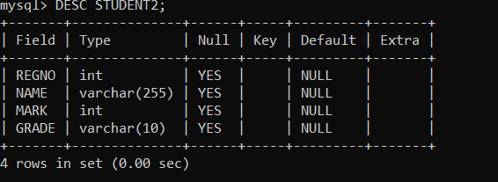

2)alter:

mysql> ALTER TABLE STUDENT2 ADD COLUMN SUBJECT VARCHAR(255);

Query OK, 0 rows affected (0.01 sec)

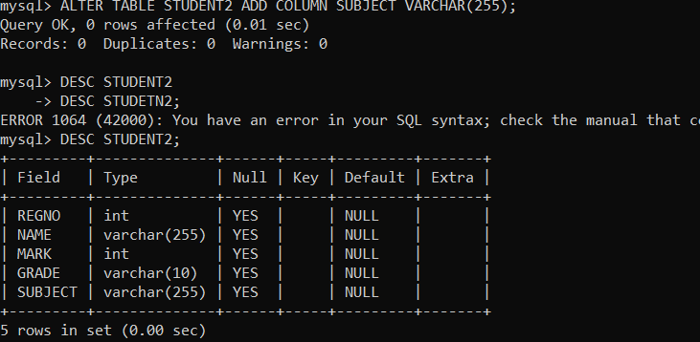

3)DROP:

mysql> DROP TABLE STUDENT2;

Query OK, 0 rows affected (0.05 sec)

